Inland Navigation Dictionary-Quiz

- Which vehicle to move or stack intermodal loading units can you see here?
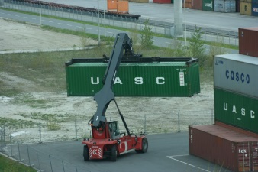
Click here to enter text.

- What is the difference between motor cargo vessels and pushed lighters (=barge)?

Click here to enter text.

- *Choose three terms connected to inland navigation you remember best and explain them:
Click here to enter text.

- *Using the following link you will find a lock operation. After watching it list all relevant terms of inland waterway you have seen:
http://www.ines-danube.info/goto.php?target=pg_927_405&client_id=viailias4

- Click here to enter text.
- Click here to enter text.
- Click here to enter text.
- Click here to enter text.
- Click here to enter text.
- Click here to enter text.

- *Explain the difference between split, combinded and intermodal transport:

Click here to enter text.

